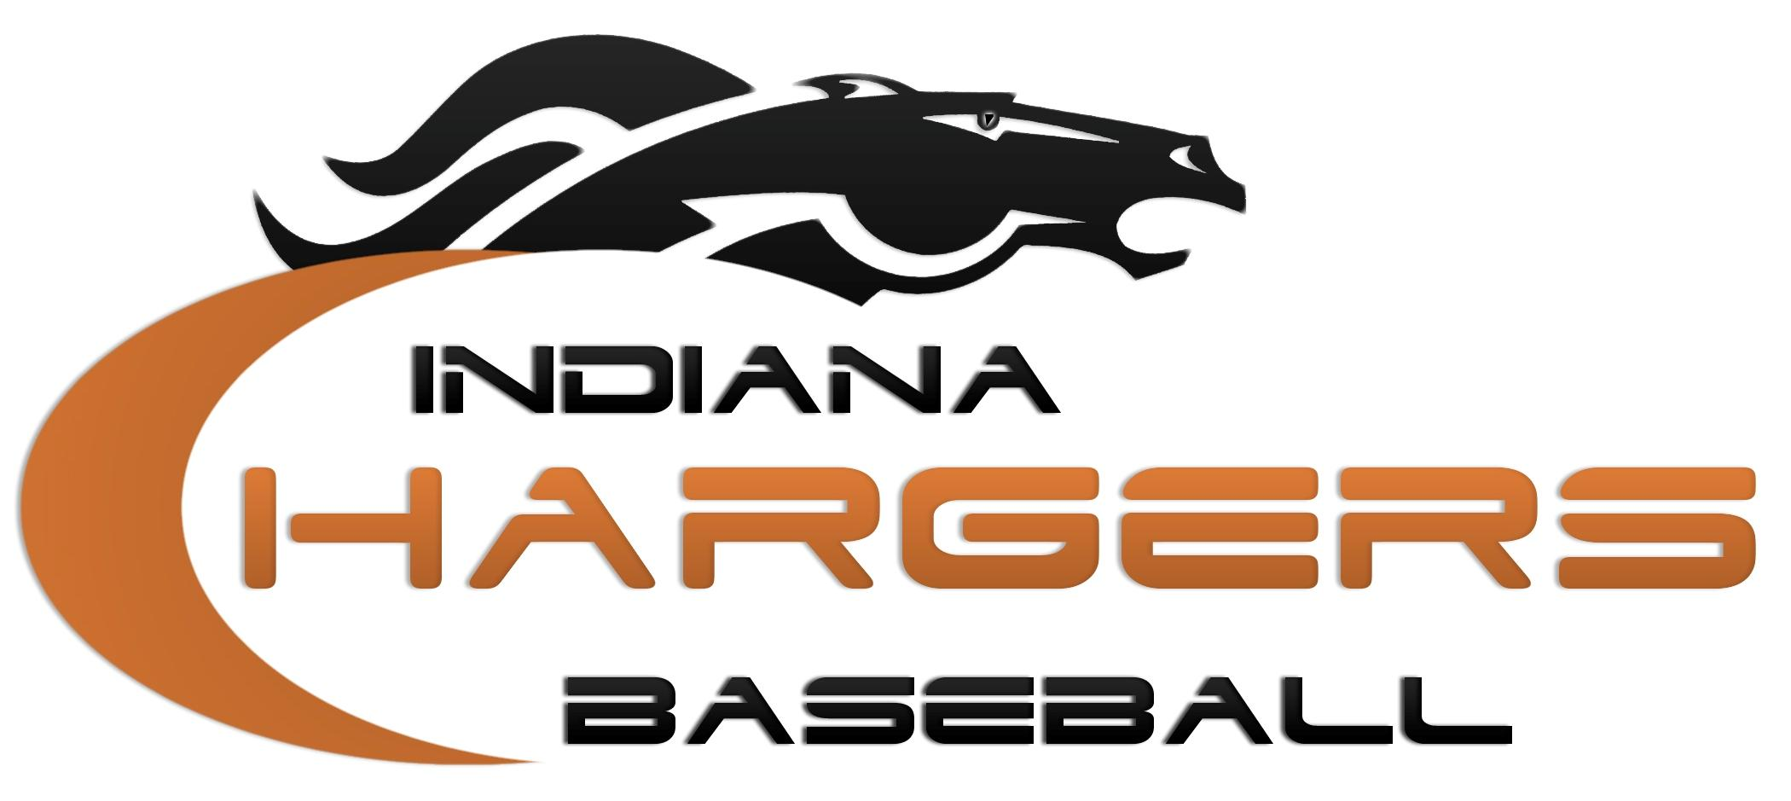
“Planning, Preparing, and Working for our Future”
2019 Corporate Sponsor Program Packet

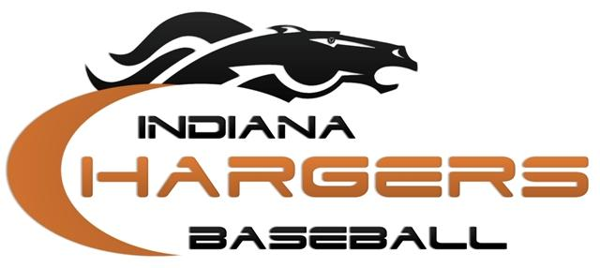
Dear Local Business Owner,
I would like to introduce you to the Indiana Chargers Baseball Club. We are an organization made up of young men from all over Northern Indiana and Southern Michigan playing together for one common goal: to give ourselves the best possible opportunity to play college baseball.
We consider ourselves fortunate to play this game for our local high schools, but it would be an even greater thrill to be able to go on and play at the college level. The Indiana Chargers Organization is one of the vehicles we, the players, are using to help us accomplish this goal.
Our club spends the majority of the spring or summer traveling to tournaments throughout the Midwest in hopes of getting noticed by college scouts who are looking for quality players to recruit for their baseball programs. These regional and national tournaments are where the scouts typically spend their summers in hopes of finding such players. Unfortunately, traveling to and playing in these tournaments comes with a significant price tag. Hotels, gas, tournament fees, uniforms, equipment, and insurance are just some of the expenses our organization faces for the upcoming 2019 season.
We are hoping that through individual player sponsorships with local businesses like you we will be able to help alleviate some of these expenses which normally fall onto the responsibility of us, the players and their families.
To operate a highly successful travel organization takes a considerable amount of time, effort, and money. In turn, my family and I are responsible for player fees and expenses around the $2,000 mark for the season. It is because of these fees that the Charger organization is offering our Corporate Sponsor Program at this time for 2019!
I hope that you will consider sponsoring me through our Corporate Sponsor Program. Please review the information that I have provided in this packet to inform you on what the program entails along with the overall ideals of our organization. Please feel free to visit our website, www.indianachargers.com, to learn more about our organization. Thank you for your consideration.

Sincerely,

Player-Indiana Chargers

About the Chargers
We are a Baseball Club consisting of players who have the aspirations for playing college baseball at some level. Along with having the necessary tools to play the college game, those tools must be accompanied by the proper make-up, attitude, and work ethic that college coaches look for in order for Charger ballplayers to achieve their goals.
Goals: Provide an avenue for kids that have aspirations to play college baseball at any level the opportunity to better themselves through both upper level instructions provided by the ECBSA (Eastlake Charger Baseball/Softball Academy) staff as well as playing against top level competition throughout the Midwest.
- Play against some of the best talent in the Midwest. The hoped results from this would be to become better baseball players through awareness of what good baseball players and good teams look like, thus motivating our ballplayers to work harder and become more dedicated to their college goals.

- Play in front of college scouts. The hoped results of this would be to teach these kids what it takes to get “focused in for the sake of the team” when scouts are there to watch individuals perform.

3. Renew and make new acquaintances with some of the areas better baseball players. The hoped results of this would be to develop relationships that can last a lifetime and learn to get along with others from a different school and community for the sake of the team.

Players: Players will be selected based on the following criteria. First, they must have a desire to be a college baseball player. This will be verified through their academic standing and high school course history, and the interest each of them has shown in working at their game. Secondly, each player must have the necessary physical and mental tools deemed necessary to play at some level of college baseball.

Charger Accomplishments

Playing at the Next Level: In the past ten years, we have helped over 158 young men reach their goals of playing baseball at the college level.

Reputation: The Chargers have built the reputation as being one of the premiere baseball clubs in the state of Indiana and in the Midwest. Other local and national programs, along with college and professional scouts, view the Chargers as a high character organization.

2019 Chargers Corporate Sponsor Program
Gold Sponsor Package
- Your company information will be featured in our “Sponsors” page on the Chargers website. This listing will include your Company’s name and contact information.

Investment: Only $250

Platinum Sponsor Package
- Your company information will be featured in our “Sponsors” page on the Chargers website. This listing will include the following: A) Company’s name and address. B) Company logo. C) Brief description of your products and services.
Investment: Only $500

Please remember, we would never ask for something and give you nothing. The Chargers will have a new team website this fall with a page dedicated to our sponsors. Also, you are not just investing in your company’s future by becoming a Corporate Sponsor. You are investing in the Indiana Chargers and even more, me personally. This sponsorship will help me reach my goal of becoming a college baseball player in the future.

“We cannot always build the future for our youth, but we can build our youth for the future.”
Franklin D. Roosevelt

2019 Charger Corporate Sponsor
Information Sheet

Date:
Company Name: Platinum or Gold Sponsor (circle one)
Address:
City, State, ZIP:
Phone Number:
Website Address:
Company Contact: Email:
Player’s Name: Email:
Amount Collected: Check Number:
Brief Company Description:

(Please make a copy of this document for the business owners file.)

Please email your company logo to (Platinum Sponsors Only) joeljmishler26@gmail.com

Have them in one of the following formats: JPEG, PNG, or GIF.

Make all checks payable to Indiana Chargers Baseball

Thank you for your support!!

Go Chargers!!!

Booster Club Information

We realize that not every company or individual is able to sponsor a player for $250 or more. We also offer a Booster Program for those of you that are in this position. Any amount under $250 that is offered by you would fall under this program.

Date:
Company Name:
Address:
City, State, ZIP:
Phone Number:
Company Contact: Email:
Player’s Name: Email:
Amount Collected: Check Number:

(Please make a copy of this document for the business owners file. There is a minimum amount of $50 for Boosters.)

Make all checks payable to Indiana Chargers Baseball

Thank you for your support!!

Go Chargers!!!

